Collection and Handling of Laboratory Samples COVID-19 (2019-nCoV)

Preparation
- For suspected Coronavirus/COVID-19/2019-nCoV patients, contact lab for collection kit
  - Coronavirus 2019-nCoV Respiratory specimen collection instructions 2.
    - synthetic flexible, floq swabs and (1) Viral transport medium. (example: Xpert Nasopharyngeal Sample Kit for Viruses)
    - CDC Person Under Investigation Case Report Form
    - Second Biohazard bag with fluorescent pink COVID-19 label affixed
- Reminder-Walk sample to the lab- do NOT transport through tube station
- Review Order
- Complete collection in an isolation room with airborne precautions (negative air pressure)
  - If a negative air pressure room is not available, follow department specific workflow
- Staff obtaining the sample need to wear the following Personal Protective Equipment (PPE), follow the CDC recommendations for use.
  - Gown
  - Respirator
  - Face Shield
  - Gloves

Obtaining Sample

For initial diagnostic testing for COVID-19, a single nasopharyngeal (NP) swab in viral transport media is acceptable. A single NP swab in viral transport media can be used to test COVID-19, Influenza, and RSV.

Exception: Aspirus Riverview Hospital and Aspirus Medford Hospital requires an additional NP swab outside of viral transport media for Influenza testing. Note: There are currently no COVID-19 tests approved for blood specimens.
- Upper Respiratory Tract Collection: (collection includes (1) swab, (1) transport tube.

  - COVID Collection includes (1) swab in a single transport tube

    - Nasopharyngeal swab
      - Tell the Patient that gagging or the urge to sneeze may occur
      - Swabbing will take less than 1 minute
      - Have the patient sit upright on edge of chair or bed, facing you
      - Visually inspect each nostril for secretions
      - Insert a swab into the nostril parallel to the palate. Keep the swab near the septum floor of the nose while gently pushing the swab into the posterior nasopharynx
      - Place swabs immediately into sterile tubes containing 2-3 ml of viral transport media, and break the swab at the indicated break line, and cap the tube

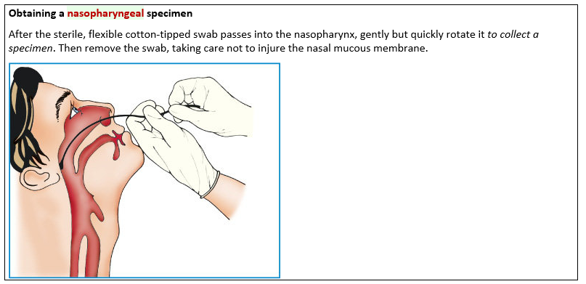
(Lippincott, 2020)

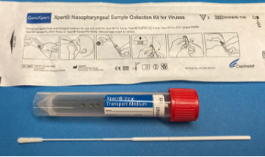
    - Clearly label
      - Source: (NP swab)
      - Patient name, DOB, Date, Time, Employee ID

Reportable Range
- Test results are reported as “detected” or “not detected”

Postmortem Collection and Submission
- Intended for specimens from deceased persons under investigation (PUI) for COVID-19 interim guideline, https://www.cdc.gov/coronavirus/2019-ncov/hcp/guidance-postmortem-specimens.html

  - Collection of post-mortem upper respiratory track swab specimens
    - Individuals in the room during the procedure should be limited to healthcare personnel (HCP) obtaining the specimen. If HCP are not performing an autopsy or conducting aerosol generating procedures (AGP’s), follow Standard Precautions
  - Engineering control recommendations:
    - Since collection of nasopharyngeal and oropharyngeal swab specimens from deceased persons will not induce coughing or sneezing, a negative pressure room is not required. Personnel should adhere to Standard Precautions as described above.
  - PPE Recommendations (The following PPE should be worn at a minimum):
    - Wear non-sterile, nitrile gloves when handling potentially infectious materials
    - If there is risk of cuts, puncture wounds, or other injuries that break the skin, wear heavy-duty gloves over the nitrile gloves
    - Wear a clean, long-sleeved fluid resistant or impermeable gown to protect skin and clothing
    - Use a plastic face shield or a face mask and goggles to protect the face, eyes, nose and mouth from splashes of potentially infectious body fluids
  - Autopsies are not performed within Aspirus facilities. If an autopsy is NOT performed, collection of the following postmortem specimens is recommended:
    - Postmortem clinical specimens for testing of SARS-CoV-2, the virus that causes COVID-19, include only upper respiratory tract swabs: Nasopharyngeal and oropharyngeal swab
    - Separate NP and OP swab specimens for testing of other respiratory pathogens
    - In addition to postmortem specimens, submission of any remaining clinical specimens (e.g. NP swab, OP swab, sputum, serum, stool) that may have been collected prior to death is recommended. Please refer to Interim Guidelines for Collecting, Handling, and Testing Clinical Specimens for Persons Under Investigation (PUIs) for Coronavirus Disease 2019 (COVID-19) for more information
    - Detailed guidance for postmortem specimen collection can be found at https://www.cdc.gov/ coronavirus/2019-ncov/hcp/guidance-postmortem-specimens.html#SpecimenCollection

Value Analysis
- Critical Value(s)
  - ARUP will consider deterred or positive results to be critical results. The client will be called and the call will be documented
  - Aspirus Reference Lab will proceed with the result as a Non-critical, infection control notification

- Interpretation of Results
  - The results are not intended to be used as the sole means for clinical diagnosis or patient management decisions

- Criteria for the Referral of Specimens to a Reference Laboratory
  - Testing for COVID-19 (2019-nCoV) will be completed by the WSLH (Wisconsin State Lab of Hygiene) or ARUP. Specimens with positive results may be forwarded to the CDC for additional testing

References
2019. Nursing Procedures, Lippincott's - 8th Ed. Philadelphia. Lippincott Williams & Wilkins. ISBN-10: 1-4698-1529-X, ISBN-13: 978-1-4698-1529-9. STAT!Ref Online Electronic Medical Library. http://online.statref.com/document/DKjwVUyF3qTr613VtEku8D!!. 3/13/2020 8:48:51 AM CDT (UTC -05:00).
Aspirus Policy- Collection and Handling of Laboratory Samples COVID-19 (2019-nCoV)

